Thank you for your interest in Equine Fest! This is our first year doing this event and we hope to have many more to follow! We have a large part of our community involved in the planning and organization of this event and because of this we anticipate a huge success! If you are interested in learning more about the Shining Light Equestrian, visit the shininglightequestrian.com.
We are looking for a variety of vendors to participate in Equine Fest. In order to register as a vendor for this event, please download the Registration Applications, fill it out, and return it with a copy of your photo ID and your proof of insurance. You will submit this to email address : admin@grofundz.com. Once your application is returned and approved, we will send you a confirmation email with the link to our payment portal. Once your payment is processed, you will be good to go!

We can’t wait to have you joint us! We are excited about sharing this journey with you!
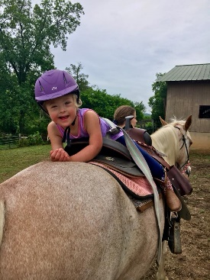
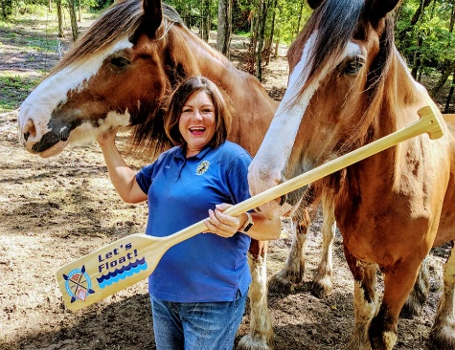
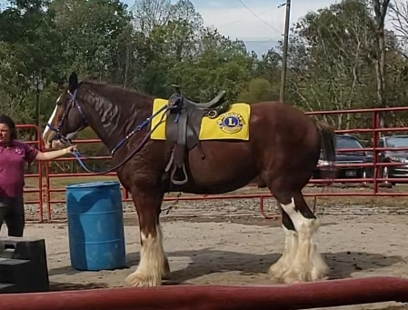
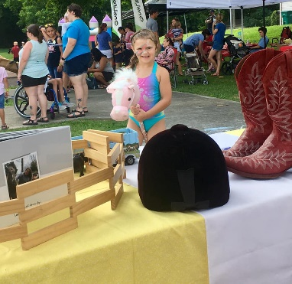
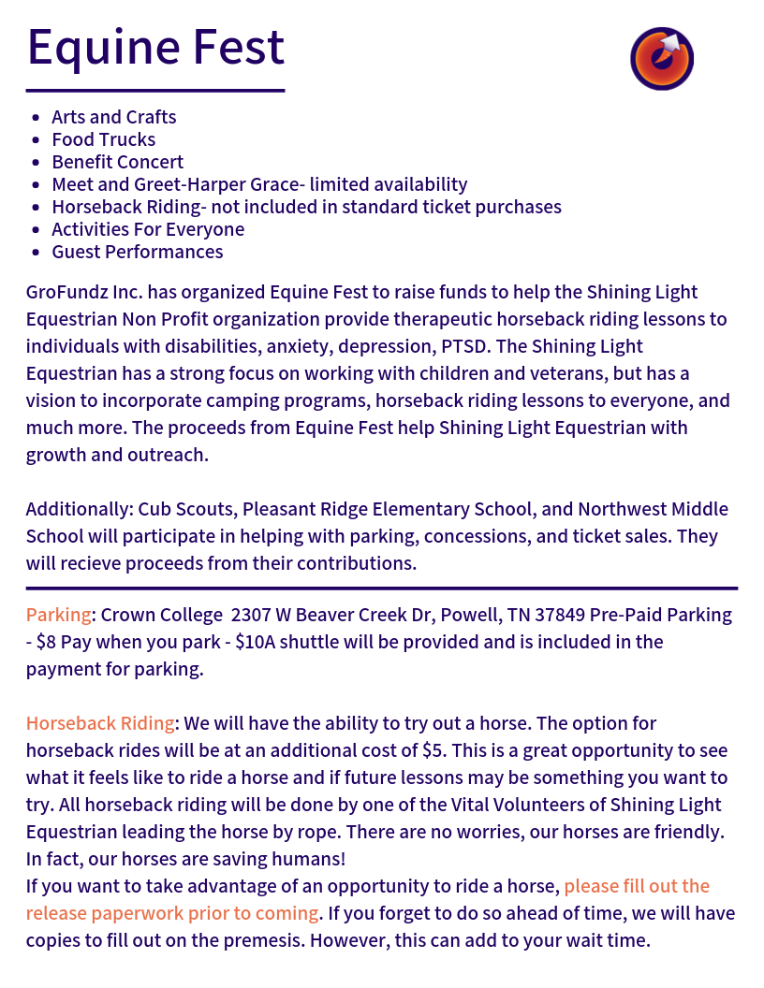
Below is the information given to our guests when they purchase their tickets

